Display Unit Selection Control Function – CGEA1.3 LOW CONTENT ONLY

Functional Description

Starting with B562 Europe, some CGEA 1.3 Low Content clusters are being developed that have OAT display, but do not have a menu structure to select units. This creates an issue for the United Kingdom, that uses miles and Celsius. The solution is to add a new configuration bit for temperature units. Since most clusters will not need this config, this is being released as “CGEA 1.3 Low Content Only” so that most clusters will not have to add this config.

The traditional selection of the cluster display units has been expanded for CGEA. High end clusters with a large display allow selecting distance units and temperature units separately.

The MetricActv_B_Actl signal is a CAN command signal that is output by the IC as a command to change the current status of the Distance Unit Selection between English and Metric units (miles or kilometers). This signal is used by the PCM/ECM for cruise control set speed display, as well as by the IPMA for speed offsets. This signal is either controlled by this STSS or the “Speedometer Secondary Scale Control Function - CGEA1.3” STSS, depending on an internal software config parameter.

The synchronization of the displayed unit settings in the vehicle is coordinated through INFOCAN for the NAV unit and the EFP or Climate Control. When the unit settings are modified in the cluster, the cluster will send the INFOCAN signals Disp_Temperature.St(Fahrenheit, Celsius) and Disp_Miles_Kilometers.St(Miles, Kilometers). Refer to the Instrument Panel Cluster (IPC) Infotainment Subsystem Part Specific Specification (SPSS) for further details. Note that the APIM works in DACC (Delayed ACCessory mode with ignition off), so the cluster will process these INFOCAN signals in Limited Mode.

The cluster is the Personalization feature owner for Units – Measure (feature 0x901) and Units – Temperature (feature 0x902). Thus, the SYNC module may send QUERY and UPLOAD and RESTORE and COPY commands for these features that the clsuter will have to respond to. (Note that on vehicles prior to MY14 with Enhanced Memory, that RESTORE and COPY and UPLOAD are not supported by SYNC)

As a summary:
When you use the cluster to switch displayed units, in CGEA 1.2 the cluster sends out an HSCAN signal and INFOCAN signals to coordinate vehicle displays (same signals but all on ICAN for CGEA 1.3). When you use the Centerstack to switch displayed units, the cluster will receive and act upon those INFOCAN signals and send out the HSCAN signal. Both of these operations affect the active profile stored in RAM and the corresponding Personality profile.

When the driver stores the current selection to a particular Personality profile, the cluster will receive the Personality COPY command. When the driver wants to restore all feature configurations back to the default settings, the cluster will receive the RESTORE command. When the driver wants to copy the current Personality to a USB device, the cluster will receive the Personality QUERY command. And finally, when the driver takes that USB device to another vehicle, that cluster will receive the Personality UPLOAD command. These signals are referenced here because the the RESTORE command does affect the active profile. For the full description of how to handle these commands, refer to the Personalization - Cluster Owned Features – Units/Language STSS.

This STSS describes the cluster menus for switching displayed units, and the HSCAN signals involved. The INFOCAN signals are partially described here for context.

Interfaces

Interface Context Diagram (I/O Block Diagram)
- Display Unit Selection Function Context Diagram
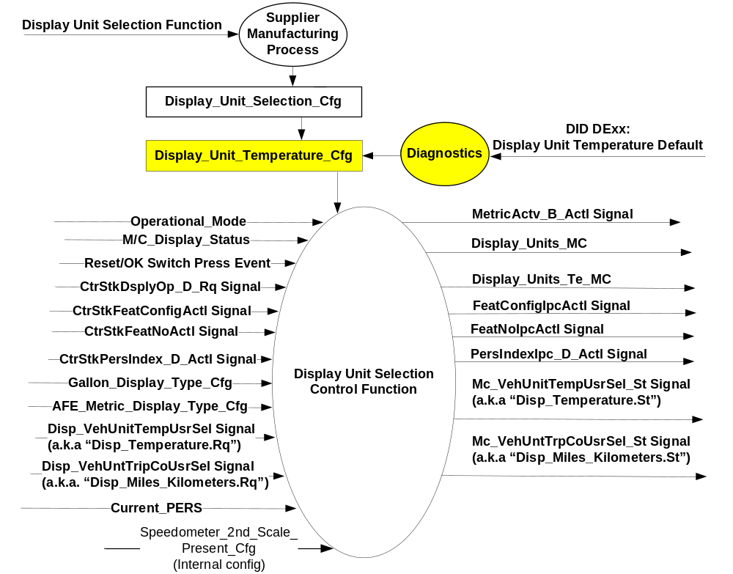

Inputs

- INTERNAL:
- Operational_Mode
- RESET/OK Switch Press Event
- M/C_Display_Status
- Display_Unit_Selection_Cfg
- Display_Unit_Temperature_Cfg
- Gallon_Display_Type_Cfg (Refer to Fuel Economy Function STSS)
- AFE_Metric_Display_Type_Cfg (Refer to Fuel Economy Function STSS)
- Current_PERS (Refer to Personalization – Cluster Owned Features – Units/Language STSS)
- Speedometer_2nd_Scale_Present_Cfg (Internal Configuration) – When “Speedometer Secondary Scale Control Function - CGEA1.3” is implemented, it has an impact on this STSS)
- MUX signals on the CAN Bus

- Personalization Input Signals
Signal Name | Size  (bits) | Detail | Units | Res. | Offset | State  Encoded | Min | Max
CtrStkFeatConfigActl | 16 | - | Undefined | 1 | 0 |  | 0  (0x0) | 65535 (0xFFFF)
CtrStkFeatNoActl | 16 | - | Undefined | 1 | 0 |  | 0  (0x0) | 65535 (0xFFFF)
CtrStkPersIndex_D_Actl | 3 |  | SED | 1 | 0 |  | 0 (0x0) | 7 (0x7)
 |  | PERS_1 |  |  |  | 0x0
 |  | PERS_2 |  |  |  | 0x1
 |  | PERS_3 |  |  |  | 0x2
 |  | PERS_4 |  |  |  | 0x3
 |  | Vehicle |  |  |  | 0x4
 |  | Unused_1 |  |  |  | 0x5
 |  | Unused_2 |  |  |  | 0x6
 |  | Unused_3 |  |  |  | 0x7
CtrStkDsplyOp_D_Rq | 3 |  | SED | 1 | 0 |  | 0 (0x0) | 7 (0x7)
 |  | Null |  |  |  | 0x0
 |  | Query |  |  |  | 0x1
 |  | Set |  |  |  | 0x2
 |  | Upload |  |  |  | 0x3
 |  | Restore |  |  |  | 0x4
 |  | Copy |  |  |  | 0x5
 |  | Unused_1 |  |  |  | 0x6
 |  | Unused_2 |  |  |  | 0x7

- INFO_CAN inputs (Refer to Blue Oval InfoCAN database)

- Disp_VehUnitTempUsrSel Signal
Signal Name | Size  (bits) | Detail | Units | Res. | Offset | State  Encoded | Min | Max
Disp_VehUnitTempUsrSel | 2 |  | SED | 1 | 0 |  | 0  (0x0) | 3 (0x3)
 |  | Celsius |  |  |  | 0x0
 |  | Fahrenheit |  |  |  | 0x1
 |  | Inactive |  |  |  | 0x3

- Disp_VehUnitTripCoUsrSel Signal
Signal Name | Size  (bits) | Detail | Units | Res. | Offset | State  Encoded | Min | Max
Disp_VehUntTripCoUsrSel | 2 |  | SED | 1 | 0 |  | 0  (0x0) | 3 (0x3)
 |  | Metric (kilometers) |  |  |  | 0x0
 |  | Imperial (miles) |  |  |  | 0x1
 |  | Inactive |  |  |  | 0x3

Outputs
- Internal
  - Display_Units_MC
  - Display_Units_Te_MC
- MUX signals on the CAN Bus.

- MetricActv_B_Actl Signal
Signal Name | Size  (bits) | Detail | Units | Res. | Offset | State  Encoded | Min | Max
MetricActv_B_Actl | 1 | - | SED | 1 | 0 |  | 0  (0x0) | 1  (0x1)
 |  | Inactive |  |  |  | 0x0
 |  | Active |  |  |  | 0x1

- Cluster Personality Data Output Signals
Signal Name | Size  (bits) | Detail | Units | Res. | Offset | State  Encoded | Min | Max
FeatConfigIpcActl | 16 | - | Undefined | 1 | 0 |  | 0  (0x0) | 65535 (0xFFFF)
FeatNoIpcActl | 16 | - | Number | 1 | 0 |  | 0  (0x0) | 65535 (0xFFFF)
PersIndexIpc_D_Actl* | 3 |  | SED | 1 | 0 |  | 0 (0x0) | 7 (0x7)
 |  | PERS_1 |  |  |  | 0x0
 |  | PERS_2 |  |  |  | 0x1
 |  | PERS_3 |  |  |  | 0x2
 |  | PERS_4 |  |  |  | 0x3
 |  | Vehicle |  |  |  | 0x4
 |  | Unused_1 |  |  |  | 0x5
 |  | Unused_2 |  |  |  | 0x6
 |  | Unused_3 |  |  |  | 0x7
* Signal PersIndexlpc_D_Actl is not supported prior to MY14 (although it may appear in message list). If it appears in program message list prior to MY14, always set to 0x4 (Vehicle). Select vehicles MY14+ support Enhanced Memory feature. This signal is required for those programs.

- INFO_CAN outputs (Refer to Blue Oval InfoCAN database)

- INFOCAN Output Signals
Signal Name | Size  (bits) | Detail | Units | Res. | Offset | State  Encoded | Min | Max
Mc_VehUntTrpCoUsrSel_St | 1 |  | SED | 1 | 0 |  | 0  (0x0) | 1 (0x1)
 |  | Metric (kilometers) |  |  |  | 0x0
 |  | Imperial (miles) |  |  |  | 0x1
Mc_VehUnitTempUsrSel_St | 1 |  | SED | 1 | 0 |  | 0  (0x0) | 1 (0x1)
 |  | Celsius |  |  |  | 0x0
 |  | Fahrenheit |  |  |  | 0x1

Function/Performance

Operational Modes

Mode | Differentiating Vehicle Conditions
Sleep Mode | Display Unit Selection Control Function Text Message Disabled
Limiting Mode | Display Unit Selection Control Function Text Message Disabled / CAN processing Enabled
Normal Mode | Display Unit Selection Control Function Text Message Enabled / Disabled
Crank Mode | Display Unit Selection Control Function Text Message Enabled / Disabled

Voltage Levels

Refer to the Cluster Features table located in the Operational Modes and Voltage Range Strategies Section in this SPSS.

Human-Machine Interface

Visual

Indicator Graphics / Display Format
For High End Display (SHMI), refer to “<Program> Cluster Menu Structure.xls”.

Home Page | Menu level 2 | Menu level 3 |  | Menu level 4 | Confirmation Text
Settings | Units | T: Units
Settings | Units | Distance |  | T: Distance Units
Settings | Units | Distance | ● | Miles & GAL | Distance Units Set to MILES & GALLONS
Settings | Units | Distance | ❍ | Km & Liters (l/100km) | Distance Units Set to KM & LITERS
Settings | Units | Distance | ❍ | Km & Liters (km/l) | Distance Units Set to KM & LITERS
Settings | Units | Temperature |  | T: Temperature Units
Settings | Units | Temperature | ● | Fahrenheit (ºF) | Temperature Set to FAHRENHEIT
Settings | Units | Temperature | ❍ | Celsius (ºC) | Temperature Set to CELSIUS

For B Display, refer to Message Center Function description reference "Text Message List - BEF Displays 2x14.xls" file - Message ID SU110

Indicator Color Coordinates

Reference section COLOR & ILLUMINATION REQUIREMENTS (GRAPHICS)

Indicator Characteristics

Refer to Message Center X Display_Y Button Interface Section, where X and Y are appropriate values in this document.

Audio

None

Switch Control Logic

Consumer access to the Display Unit Selection Control Configuration shall be as specified in the message center basic functionality display as specified in Message Center X Display_Y Button Interface Section, where X and Y are appropriate values in this document.

System Accuracy

Within a 100msec of receiving a message that results in a change of state the cluster will update the display to the proper status.

Operation: Performance and Functional

Subsystem Algorithm Flowchart / State Diagram

- Default Temperature Diagnostic Configuration Flowchart

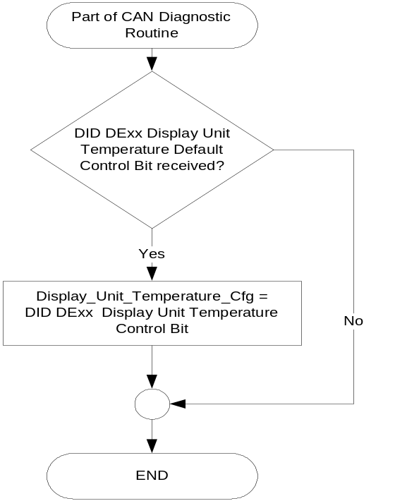

- Display Unit Selection Flowcharts – INFOCAN signals
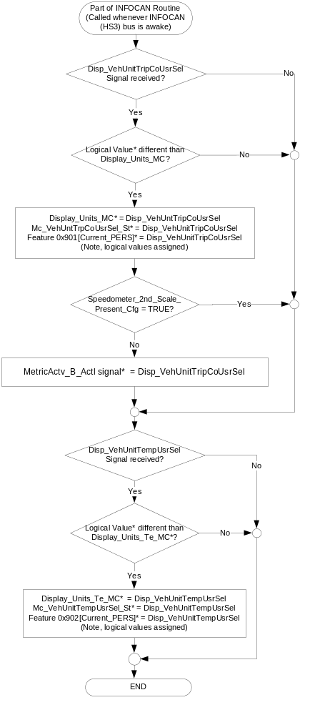

* For ease of understanding, we are referencing the "logical" value (i.e. "Metric" or "Celsius"). This is because several signals are involved with different encodings (i.e. "1" equals Celsius in one signal, and "0" equals Celsius in another). The "*" in the equations is similarly an assignment operator of the logical values.

- Display Unit Selection Flowcharts – Display_Units_MC & Display_Unit_Te_MC

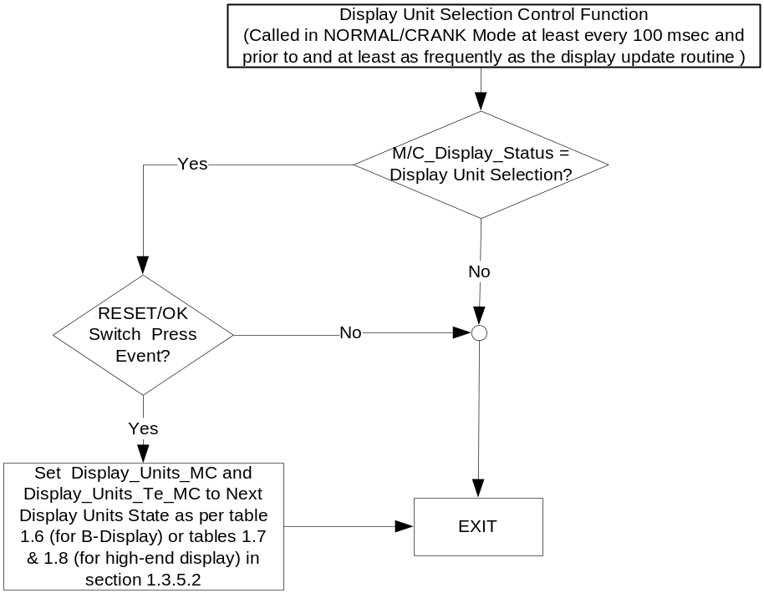

NOTE: In the Display Unit Selection Function Flowchart, the definition of "RESET Switch Event" is defined in Message Center X Display_Y Button Interface Section, where X and Y are appropriate values in this document.

- Display Units Selection Flowcharts – Profile Recall

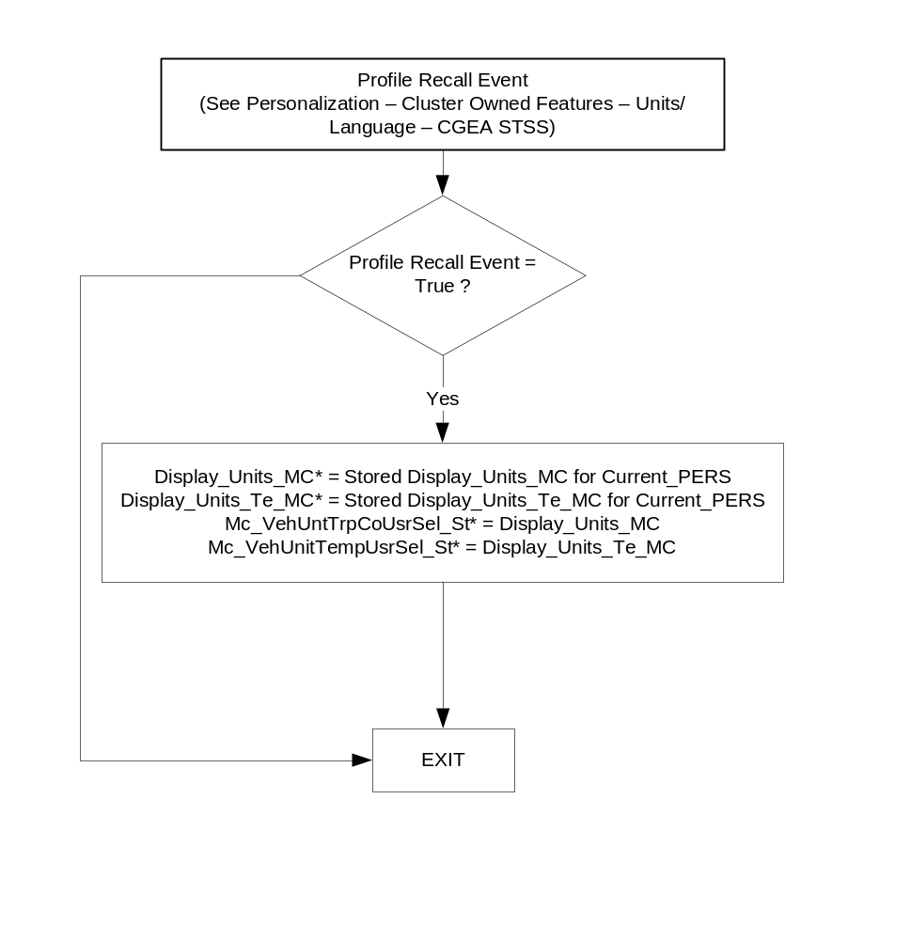
* For ease of understanding, we are referencing the "logical" value (i.e. "Metric" or "Celsius"). This is because several signals are involved with different encodings (i.e. "1" equals Celsius in one signal, and "0" equals Celsius in another). The "*" in the equations is similarly an assignment operator of the logical values.

Operation Description (supports algorithm flowchart /state diagram)

- Message Center Display (B-Display) and Next Display Unit Selection
Display_  Units_MC | MetricActv_B_Actl Signal* | Gallon_Display_Type_Cfg | AFE_  Metric_  Display_  Type_Cfg | Message Center Display  Message ID: SU110 | Next Display_Units_MC State | Next  Display_Units_Te_MC State
English (0x0) | Inactive (0x0) | X | 0 (l/100km) | UNITS  <ENGLISH>METRIC | Metric (0x2) | Metric (0x1)
English (0x0) | Inactive (0x0) | X | 1 (km/l) | UNITS  <ENGLISH>METRIC | Metric (0x3) | Metric (0x1)
English (0x1) | Inactive (0x0) | X | 0 (l/100km) | UNITS  <ENGLISH>METRIC | Metric (0x2) | Metric (0x1)
English (0x1) | Inactive (0x0) | X | 1 (km/l) | UNITS  <ENGLISH>METRIC | Metric (0x3) | Metric (0x1)
Metric (0x2) | Active (0x1) | 0 (US Gal) | X | UNITS  ENGLISH<METRIC> | English (0x0) | English (0x0)
Metric (0x2) | Active (0x1) | 1 (UK Gal) | X | UNITS  ENGLISH<METRIC> | English (0x1) | English (0x0)
Metric (0x3) | Active (0x1) | 0 (US Gal) | X | UNITS  ENGLISH<METRIC> | English (0x0) | English (0x0)
Metric (0x3) | Active (0x1) | 1 (UK Gal) | X | UNITS  ENGLISH<METRIC> | English (0x1) | English (0x0)

* Ignore this column when Speedometer_2nd_Scale_Present_Cfg = TRUE.

- High End Display – Distance Unit Selection
Display_Units_MC | MetricActv_B_Actl Signal * | Gallon_ Display_ Type_Cfg | Current Display Menu  (Level 4) | 5-Button  Switch  Selection Event | Next Display_Units_  MC State
English (0x0) | Inactive (0x0) | X | 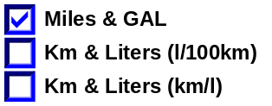 | Up/Down + OK (Select l/100km or km/l) | If l/100km selected:  Metric (0x2)  Else km/l selected  Metric (0x3)
English (0x1) | Inactive (0x0) | X |  | Up/Down + OK (Select l/100km or km/l) | If l/100km selected:  Metric (0x2)  Else km/l selected  Metric (0x3)
Metric (0x2) | Active (0x1) | 0x0 (US Gal) | 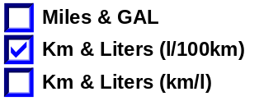 | Up/Down + OK (Select Miles & GAL or km/l) | If Miles and GAL selected:  English (0x0)  Else km/l selected  Metric (0x3)
Metric (0x2) | Active (0x1) | 0x1 (UK Gal) |  | Up/Down + OK (Select Miles & GAL or km/l) | If Miles and GAL selected:  English (0x1)  Else km/l selected  Metric (0x3)
Metric (0x3) | Active (0x1) | 0x0 (US Gal) | 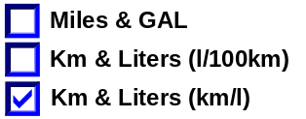 | Up/Down + OK (Select Miles & GAL or l/100km) | If Miles and GAL selected:  English (0x0)  Else l/100km selected  Metric (0x2)
Metric (0x3) | Active (0x1) | 0x1 (UK Gal) |  | Up/Down + OK (Select Miles & GAL or l/100km) | If Miles and GAL selected:  English (0x1)  Else l/100km selected  Metric (0x2)

* Ignore this column when Speedometer_2nd_Scale_Present_Cfg = TRUE.

- High End Display – Temperature Unit Selection
Display_Units_Te_MC | Current Display Menu  (Level 4) | 5-Button  Switch  Selection Event | Next Display_Units_  Te_MC State
English (0x0) | 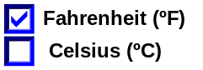 | Up/Down + OK (Select ºC) | Metric (0x1)
Metric (0x1) | 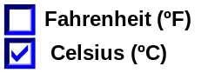 | Up/Down + OK (Select ºF) | English (0x0)

- Default Values for Distance and Volume
Display_  Unit_  Selection  _Cfg | Gallon_  Display  _Type_Cfg | AFE_  Metric_  Display_  Type_Cfg | Display_  Units_MC | MetricActv  _B_Actl | Mc_  VehUntTrpCoUsrSel  _St | 0x901
(0x0) English | 0x0  (US Gal) | X | English (0x0) | Inactive (0x0) | Imperial (miles)  (0x1) | Miles/ Gallon  (0x0)
(0x0) English | 0x1  (UK Gal) | X | English (0x1) | Inactive (0x0) | Imperial (miles)  (0x1) | Miles/ UK Gallon  (0x1)
(0x1) Metric | X | 0 (l/100km) | Metric (0x2) | Active  (0x1) | Metric (kilometers)  (0x0) | liter/100km  (0x2)
(0x1) Metric | X | 1 (km/l) | Metric (0x3) | Active  (0x1) | Metric (kilometers)  (0x0) | km/liter  (0x3)

- Default Values for Temperature
Display_Unit_Temperature_Cfg | Display_Units_Te_MC | Mc_VehUnitTempUsrSel_St | 0x902
(0x0)  Fahrenheit | English  (0x0) | Fahrenheit  (0x1) | Fahrenheit  (0x0)
(0x1)  Celsius | Metric  (0x1) | Celsius  (0x0) | Celsius  (0x1)

- Values for Distance and Volume
Display_Units_MC | MetricActv_B_Actl* | Mc_VehUntTrpCoUsrSel_St | 0x901
English (0x0) | Inactive (0x0) | Imperial (miles)  (0x1) | Miles/ Gallon  (0x0)
English (0x1) | Inactive (0x0) | Imperial (miles)  (0x1) | Miles/ UK Gallon  (0x1)
Metric (0x2) | Active  (0x1) | Metric (kilometers)  (0x0) | liter/100km  (0x2)
Metric (0x3) | Active  (0x1) | Metric (kilometers)  (0x0) | km/liter  (0x3)

* Ignore this column when Speedometer_2nd_Scale_Present_Cfg = TRUE.

- Values for Temperature
Display_Units_Te_MC | Mc_VehUnitTempUsrSel_St | 0x902
English  (0x0) | Fahrenheit  (0x1) | Fahrenheit  (0x0)
Metric  (0x1) | Celsius  (0x0) | Celsius  (0x1)

- This feature will be set to the appropriate value due to the speedometer major graphic unit at the instrument cluster manufacturing plant. Display_Unit_Selection_Cfg will equal (0X0) English when speedometer major graphic unit is MPH. Display_Unit_Selection_Cfg will equal (0X1) Metric when speedometer major graphic unit is Km/h.

Function Safety Classification (EMC)

Class B

Memory Storage

Parameter Name | Description | Value at  Battery Connect | Value at Module Wake-up
MetricActv_B_Actl Signal | This is the value transmitted in the CAN signal. This output indicates if the Distance units are in English or Metric Mode. This signal is always logically the same as Display_Units_MC. (i.e. follows the display) (Note that this signal is also the combined distance and temperature units on the Base cluster) | Used Stored Value of Display_Unit_Selection_Cfg | Do Not Init
Speedometer_2nd_Scale_  Present_Cfg | Internal configuration used to identify when “Speedometer Secondary Scale Control Function - CGEA1.3” STSS is implemented on a program. When TRUE, this has an impact on “Display Unit Selection Control Function – CGEA 1.3” STSS. Only 1 of these 2 STSS’s can modify MetricActv_B_Actl Signal. (i.e. When Speedo Secondary Scale has been implemented, then only that STSS shall affect signal MetricActv_B_Actl).  When “Speedometer Secondary Scale Control Function - CGEA1.3” is implemented AND the secondary scale menu option is available in the cluster menu set to TRUE (0x1), else set to FALSE (0x0). | Use Stored Value | Use Stored Value
Display_Units_MC | Output that controls display indicating units to the driver (i.e. when English: miles, mpg; when Metric: km, L/100 km, km/L). Parameter is to be stored in Battery Backed RAM. Has same definition as Personality Feature 0x901 [4].  See Table 1.9 for initial value. | Used Stored Value | Do Not Init
Display_Unit_Temperature_Cfg | Parameter sets initial temperature units.  Supplier shall set default to match speedometer major units. Then, Ford EOL may over-ride for Britain/United Kingdom.  Default set at cluster supplier manufacturer plant.  This NVM parameter shall be set equal to (0X0) Fahrenheit when speedometer major graphic unit is MPH and (0X1) Celsius when speedometer major graphic unit is Km/h. (i.e. shall match Display_Unit_Selection_Cfg).  In summary, Great Britain (i.e. England/United Kingdom) is an exception that uses miles and Celsius. This default was added for very low end clusters that display OAT but do not have a menu to switch temperature units. | Use Stored Value | Use Stored Value
Display_Units_Te_MC | Output that controls display indicating Temperature units to the driver (i.e. when English: Fahrenheit; when Metric: Celsius). Parameter is to be stored in Battery Backed RAM. See Table 1.10 for initial value. | Used Stored Value | Do Not Init
Display_Unit_Selection_Cfg | Configures cluster for default Display Unit Selection. (Set at cluster supplier manufacturer plant). This NVM parameter shall be set equal (0X0) English when speedometer major graphic unit is MPH and (0X1) Metric when speedometer major graphic unit is Km/h. | Use Stored Value | Use Stored Value
Gallon_Display_Type_Cfg | EOL configures cluster for the type of gallon to use in the AFE display. This NVM parameter shall be set equal (0x0) for US Gallons, and (0x1) for UK Gallons. (1 US Gallon = 0.832675 UK Gallon = 3.7854 Liters)  See FE STSS for Defaults. | Use Stored Value | Use Stored Value
AFE_Metric_Display_  Type_Cfg | EOL configures cluster for the type of units to use in the AFE display. This NVM parameter shall be set equal (0x0) for Liters/100Km, and (0x1) for Km/Liter.  See FE STSS for Defaults. | Use Stored Value | Use Stored Value
M/C_Display_Status | State Indicator to identify which text is currently being displayed on Message Center display. See * | See * below | See * below
RESET/OK Switch Press Event | Event that is indicated as per the switch interface for the Message Center *.  On a B-Display, RESET is used. On high-end display, OK switch is used for selection. | See * below | See * below
Operational_Mode | 4 state indicator for cluster operational mode | Limited | Limited, Normal or Crank

* Refer to Message Center X Display_Y Button Interface Section, where X and Y are appropriate values in this document.

Reconfigurable Telltale

Not Applicable

Prove Out

Not applicable

Message Center Msg

Refer to Message Center Function description reference "Text Message List - BEF Displays 2x14.xls" file - Message ID SU110

Error Handling

No missing message strategy defined for these input signals.

Diagnostics

Self Test

None

Engineering Test Mode

None

Part II Performance

DID DExx
Byte(s) | State: Description | "0" | "1" | Default | Comments/  Information
1 | Display Unit Selection Function | English | Metric | Must match applique if applique is unique for English or Metric | Use is Optional (Best for Virtual/Digital Speedos. Another typical method is an internal bit that would not require EOL configuration  Not customer preference;
1 | Display Unit Temperature Default | Fahrenheit | Celsius | Must follow applique if applique is unique for English or Metric | THis should be limited to CGEA 1.3 Low Content clusters.  Parameter sets initial temperature units.  This parameter is set by default by the supplier to follow the speedometer major graphic units. Thus, the VSCS can either “brute force” all clusters to either Fahrenheit or Celsius, or the VSCS can just program in any exceptions to the rule (i.e. for UK, set to Celsius).  Set to Celsius (0x1) for all clusters with Metric major speedometers OR if Great Britain (United Kingdom).  Set to Fahrenheit (0x0) for all clusters with English major speedometers UNLESS Great Britain (United Kingdom).  In summary, Great Britain (i.e. England/United Kingdom) is an exception that uses miles and Celsius. This default was added for very low end clusters that display OAT but do not have a menu to switch temperature units.

Reference Specification

None

Revision History
SPSS Module Revision History

Revision Level | Name | Change Description | Date
1.0 | V. Patel | Updated for CGEA 1.3 based on CGEA STSS v2.3  Section 1.2.2 – Removed table referencing the HS-CAN message that contains the input signals.  Section 1.2.3 – Removed table referencing the HS-CAN message that contains the output signals.  Section 1.2 – Deleted “Position” and “ID” columns from the input and output signal tables.  Deleted “U38x/U502” from the title since this STSS is applicable to all “Car” platforms. | 10/26/2010
2.0 | S. Watkins | The menu has changed to show “km/L”. Also, since in CGEA 1.2+ there is no longer a need for a “car” STSS and a “truck” STSS. Thus the truck STSS has been deleted and this is the only STSS.  - Section 1.1 – Added comments that UPLOAD, RESTORE, COPY no longer applicable.  - Re-wrote Table 1.7. Also expanded variable Display_Units_MC to 2 bits, matching personalization feature 0x0901 definition.  - Modified first bullet below Table 1.8 per new definition of Display_Units_MC.  - Section 1.3.5.4 – Slightly changed description of Display_Units_MC per above. | 3/11/2011
2.1 | S. Watkins | Corrected typos in signal names, and noted that signal PersIndexIpc_D_Actl is not supported.  - Section 1.2.3 table 1.4 strikethrough "Perslndexlpc_D_Actl" and its details and added note underneath "Signal PersIndexlpc_D_Actl no longer supported ";  - In Table 1.5, "Mc_VehUnitTripCoUsrSel_St" changed to "Mc_VehUntTrpCoUsrSel_St" | 5/11/2011
2.2 | T. Cwik | Updates for clarification:  - Section 1.2.1 – Figure 1 Added Gallon_Display_Type_Cfg and AFE_Metric_Display_Type_Cfg  - Section 1.2.2 – Added Gallon_Display_Type_Cfg and AFE_Metric_Display_Type_Cfg  - Section 1.3.5.2 – Updated Tables 1.6, 1.7 and 1.8, added Tables 1.9, 1.10, 1.11 and 1.12 and updated the tic points.  - Section 1.3.5.4 – Added Gallon_Display_Type_Cfg and AFE_Metric_Display_Type_Cfg and updated Display_Units_MC, Display_Units_Te_MC | 9/20/2011
2.3 | S. Watkins | Minor cleanup to support Enhanced Memory. Remove strikeout from PersIndexIpc_D_Actl, etc.  - Section 1.1 – Updated 4th paragraph  - Section 1.2.3 – Removed strikeout from Table 1.4, signal PersIndexIpc_D_Actl and modified note below table. | 8/31/2012
2.4 | T. Cwik | Minor cleanup to identify the _Cfg variable  - Added content of Section 1.5.3 | 7/30/2013
2.5 | T. Cwik | Minor cleanup for FE units  - Section 1.3.5.4 – Deleted “(Km/Liter is Japan only)” from AFE_Metric_Display_Type_Cfg | 3/20/2015
3.0 | S. Watkins | It was realized that clusters with new HMI that follow the “Speedometer Secondary Scale Control Function - CGEA1.3” STSS need to modify the CAN signal MetricActv_B_Actl. To avoid a conflict, we defined an internal config to indicate if that STSS is supported (Speedometer_2nd_Scale_Present_Cfg). If this config is TRUE, then this STSS will NOT modify the value of MetricActv_B_Actl.  Changes highlighted in green:  - Secton 1.1 – Added description  - Section 1.2.1 – Added Speedometer_2nd_Scale_Present_Cfg to Figure 1  - Section 1.2.2 – Added Speedometer_2nd_Scale_Present_Cfg  - Section 1.3.5.1 – Figure 2, added IF,THEN,ENDIF statement for Speedometer_2nd_Scale_Present_Cfg  - Section 1.3.5.2 – Added note to ignore MetricActiv_B_Actl when Speedometer_2nd_Scale_Present_Cfg = TRUE to Table 1.6, Table 1.7, and Table 1.11.  - Section 1.3.5.4 – Added Speedometer_2nd_Scale_Present_Cfg | 12/9/2015
3.1 | S. Watkins | A logic error wasfound during review. The IF, THEN, ENDIF statement in change #4 above was wrong. We have to change “==” to “<>”. (Equal to NOT Equal). To make this clear, Figure 2 was re-drawn with decision diamonds. | 12/10/2015
4.0 | S. Watkins | Updating this STSS to make it clear that INFOCAN (HS3) signals need to be processed in Limited mode (i.e. ignition in OFF or ACC with cluster still awake). There is currently a system issue since SYNC (APIM) functions in DACC (Delayed Accessory with ignition off). If you change the units via SYNC when in DACC, the cluster will not change. To correct this, adding requirements to show correct ignition mode processing.  Changes shown in blue:  - Section 1.1 – Added comment about APIM working in DACC  - Section 1.3.1 – Added Processing of CAN signals in Limited mode, and display of text messages in CRANK.  - Section 1.3.5.1 – Figure 2 – Modified Entry bubble to clarify that this routine runs any time INFOCAN is awake.  - Section 1.3.5.1 – Figure 3 – Modified Entry bubble to clarify that this routine runs during CRANK (in addition to NORMAL mode). | 1/7/2016
1.0 CGEA 1.3 - Low Content Only | S. Watkins | This is a change specifically for CGEA 1.3 LC (Low Content). We did not want the new config to be carried across all CGEA 1.3 programs, so this “Low Content Only” version has been created.  The B562 Eu cluster has OAT display, but does not have a menu at all for units. Thus, England (UK) requirements are not met, since they require Miles and Celsius. The solution is to add a new default config bit for temperature units. (Right now the default temperature follows the speedometer major units).  All changes highlighted in yellow.  - Section 1.0 – Modified name to “Low Content Only”  - Section 1.1 – Updated description  - Section 1.2.1 – Figure 1 – Added new DExx config for temperature units (Display_Unit_Temperature_Cfg)  - Section 1.3.5.1 – Added new Figure 2 for DExx config  - Section 1.3.5.2 – Modified 1st column of Table 1.10 to use Display_Unit_Temperature_Cfg.  - Section 1.3.5.4 – Added Display_Unit_Temperature_Cfg  - Section 1.5.3 – Added new DExx Display_Unit_Temperature_Cfg. | 2/29/2016

